THE MINORITY ATTACK: Pawn Advance Along A Flank
By
GM Bong Villamayor
Powerchess Asia

The minority attack features an attack using pawns against an enemy pawn position that may result into a weakness of the structure. This resulting attack becomes a permanent feature of the position.

Once a weakness is formed, the attacker can lay siege on it and place the opponent on the defensive. This form of attack is one of the classical ideas of strategy based on pawn structures.
We now take up one of the most important pawn configuration “The Carlsbad Structure”.
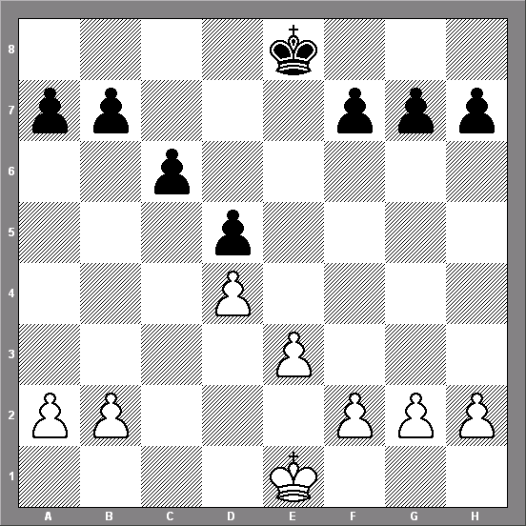

White’s plan is to play b4-b5 followed by b5xc6; Black in turn b7xc6 resulting in a ‘backward pawn’ in an open file, this is the targeted weakness.

Keres,P - Najdorf,M [D36]
Margate (7), 1939
1.d4 Nf6 2.c4 e6 3.Nc3 d5 4.Bg5 Be7 5.e3 0–0 6.Nf3 Nbd7 7.cxd5 exd5 8.Bd3 c6 9.Qc2 Re8 10.h3 Nf8 11.0–0 Nh5 12.Bxe7 Qxe7 13.Rab1 Nf6 14.b4 Be6 15.Na4 Before White makes the move b4-b5 he must avoid the threatening advance c6-c5.
15...Ne4 16.Nc5 Nd6 17.a4 f6 A passive plan. Better was 17...Rac8 and once the queen has left c2, Black could prepare for b4-b5 with Be6-f5 exchanging bishops and launching central counter play. , 18.Rfc1 Bf7 19.Nd2 g6 20.b5 cxb5 Black chose to go on with a weakness on d5.
21.axb5 Rec8 22.Qb3 Nd7 23.Qb4 Consolidates the c5-point and creates the dangerous threat 24.Nxb7. 23...Ne4 Loses by force. However, Black could hardly hope to defend his
position after other continuations as well. 24.Ndxe4 dxe4 25.Bxe4 b6 26.Bxa8 bxc5 27.Rxc5 Nxc5 28.Bc6 a6 29.dxc5 axb5 30.Qxb5 Black resigned. 1–0

Tactics: Try to solve!
Black to play Black to play White to play
